Nuclear Experiments

The series of experiments included in this notes provide an introduction to some techniques that are currently used to study nuclear science and a framework to help the student learn. The methodology, list of equipment, and step-by-step instructions that are needed are included in each experiment, together with sufficient reference material and theoretical information about the experiment to help the student interpret results.

EXPERIMENT 1
RECORD FROM THE OSCILLOSCOPE THE PULSE COMING FROM A NAI(Tl) GAMMA SHINTILLATION DETECTOR

Purpose. Gamma rays from the source produce pulses from the detector whose amplitudes are proportional to the energies of the gamma rays

Equipment needed:  - 1 microcurie of Americium 241  - HV Power Supply from Canberra Series 10x MCA  - Digital Oscilloscope  - NaI(Tl) gamma scintillation detector: 2 wire versions for individual HV and signal feedlines. | 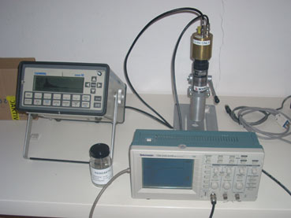

PROCEDURE
1. Connect a 5-ft (or shorter) cable, type RG-58/U with BNC connectors, from the direct output of the NaI(Tl) gamma scintillation detector to the channel 1 input of the Oscilloscope. This is known as receiving-end termination and in this case simulates the input impedance of a preamplifier.
2. Center the source on the detector axis at a distance from the detector that establishes a counting rate of about 500 s-1.
3. You may need to verify that the HV is turned ON.
4. Trigger the oscilloscope by adjusting the Triggering Level Control. When the oscilloscope is operating properly, the output should appear approximately as that shown in Fig. 1

. The voltage height adjustment on the oscilloscope was set to 0.5 volts per division to compute the amplitude visually. The pulse amplitude showed 4.9 vertical divisions which calculated to 2.46 volts. The time knob on the oscilloscope used to expand the pulse was set at 50 microseconds per division in order to compute the fall time. The fall time was calculated to be 250 microseconds because the pulse that was measured from the peak to the last 20 percent of the tail was 5 divisions horizontal. The time knob was then set to 2 milliseconds per division to shorten the number of divisions between pulses until two pulses were seen in the same window to calculate frequency.
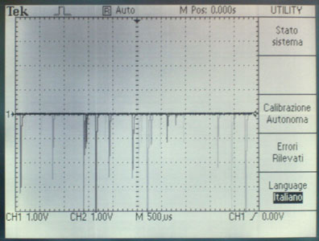

Figura 1 Oscilloscope display: wide view. Notice how the pulse have different amplitude.

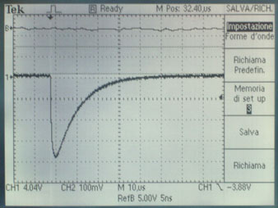 | 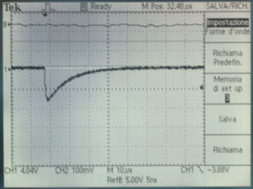
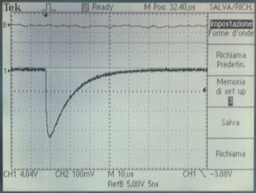 | 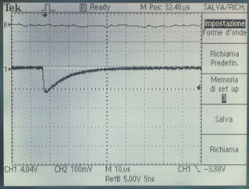
Figura 2 Oscilloscope display: images at various peaks. As you will notice close observation reveals the short rise time of the pulse while its decay time has the characteristic of the discarge of a RC circuit.

EXPERIMENT 2
GAMMA-RAY SPECTROSCOPY USING NAI(Tl)

Purpose. When a gamma-ray (photon) is absorbed by a NaI detector, a small signal (often termed a pulse) is produced. The signal is amplified and filtered in such a way as to reduce noise and produce a "clean" signal.
The magnitude of the net signal is proportional to the energy of the photon (i.e., photons with greater energies produce larger pulses). A device called an Analog To Digital Converter (ADC) is used to convert each pulse into a channel number (larger pulses will be converted into a higher channel). Each pulse is registered as a count in a unique channel by the Multichannel Analyzer (MCA). The result is a histogram of pulses (called a spectrum) displayed as counts in channels in the MCA that shows the resulting spectrum.
Since the system has no advance knowledge of the energy of the incident photons, an energy calibration is performed to assign the correct energies to appropriate channel numbers. The energy calibration is performed by counting a standard source with known nuclide energies and instructing the MCA to define channel numbers in terms of known energies. This information is then used to evaluate unknown spectra. The source may contain a single nuclide (e.g., Eu-152), or a mixture of gamma emitters such as Am 241 or Ra 226. Notice that the number of net counts is the area of the peak of the spectra above the background.
The key parameters for controlling the MCA are the conversion gain and memory size. Conversion gain and memory size of 1024 are usually recommended since the pulse height voltage is approximately the channel number / 100. The MCA’s input voltage range is 0- 10 V.Using zero offset can reduce the number of channels by allowing the shifting of the origin. A major benefit of zero offset is to cut off larger pulses in order to see smaller pulses easier.

TAG NO. SERIES 10 29 AUG 07 23:39 PAGE 1

MEMORY= 1/1 LIVE TIME=- 200 SECS TRUE TIME= 203 SECS

COLLECT STARTED ON 29 AUG 07 AT 23:19:16

AMP: INPUT= POS TC=FAST GAIN= 25.000

SCA: LLD= 0% ULD= 110.0%

ADC: GAIN=4096 OFFSET= 0 ZERO= 0%

PHA ADD PRESET= 200s LT

HVPS: - 750V ON STABLZ OFF

Smoke Detector Spectrum
Ionizing smoke detectors contain approximately 1 microcurie of Americium 241. This is an alpha emitter and the flux of alpha particles is measured by the unit to determine if smoke is present between the Am-241 source and the detector. Am-241 also emits low energy gamma-rays which were measured here. The gamma-ray spectrum obtained is shown in the following plot. The two prominent gamma rays from Am-241 can be easily seen.

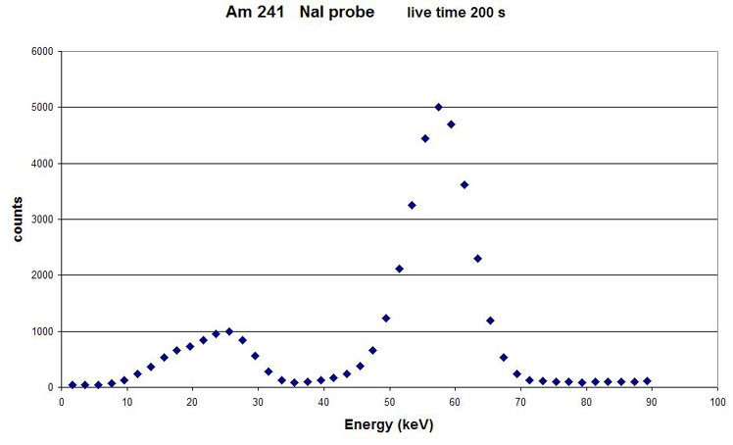
Figura 3

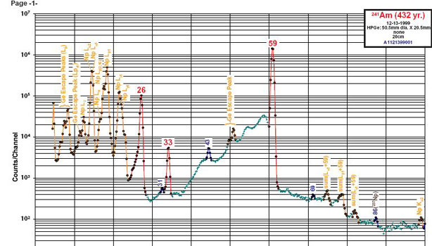

Figura 4 Gamma spectrum of Am 241 from the web resource: http://www.radiochemistry.org/periodictable/gamma_spectra/

Decay Products of Ra-226 Uranium-238 decays to lead-206 by processes of and emission, as shown in Figure 3. Many of the intermediate daughter nuclei are emitters, one of which is Ra226. Obtain a spectrum from the Ra226 source. You may have to collect data for several hours to resolve the important features clearly. Determine the energies of as many lines as you can, and, using tables in the CRC Handbook of Chemistry and Physics as a guide (or other web reference such as: http://www.radiochemistry.org/periodictable/gamma_spectra/), identify the decay products and discuss the various modes of decay associated with. Ra226.
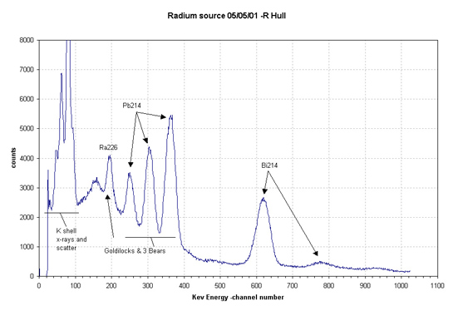
Figura 5: gamma spectrum of Ra 226 from the web

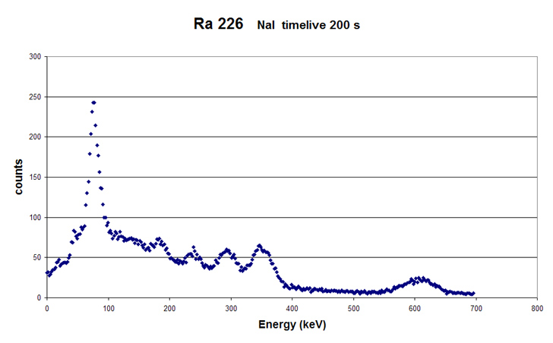
Figura 6. As you can see, most of the significant gamma radiation from ²²⁶Ra decay comes from the radioactive progeny ²¹⁴Pb and its daughter, ²¹⁴Bi. These are produced following the decay of ²²⁶Ra to ²²²Rn, which then decays to ²¹⁴Pb.

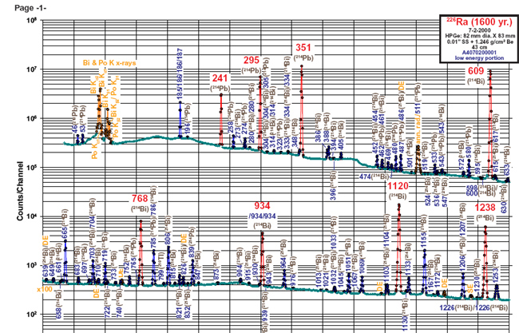
Figura 7. Gamma spectrum of Am 241 from the web resource: http://www.radiochemistry.org/periodictable/gamma_spectra/

Thoriated lenses

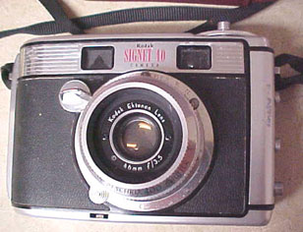

Older commercial lenses contain Thorium-232. All Thorium isotopes (and its decay products)are radioactive. Thorium was added to increase the index of refraction of the lenses. The fact that thorium is radioactive was irrelevant. The first use of thoriated lenses seems to date from the late 1930s or WW II. The production of thoriated camera lenses seems to have ceased in the late 1980s.
Thorium emits alpha, beta, and gamma radiation. For cameras employing thoriated lenses, only the gamma rays result in a dose to the lens of the eye (or any other part of the body for that matter).

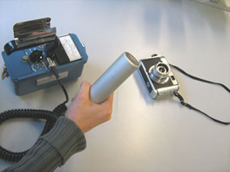 | 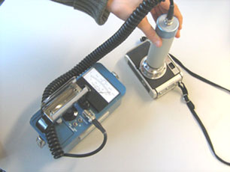

The meter of a Geiger-Muller probe pegged at over 1600 counts/min (background was 50 counts/min)

The major determinant of the dose to the lens of the eye is the length of time the photographer is holding the camera up to the head. As an example, the dose rate near the viewfinder of an old Pentax camera of mine (Super Takumar lens) is roughly 100 microrad per hour—approximately ten times background. In other words, looking through the viewfinder of this camera for one minute results in the same dose that I receive every ten minutes when not using it. I would have to hold this camera up to my eye for several million hours to potential consequence such as cataracts. The development of cataracts as a result of a radiation exposure is referred to as a "nonstochastic" or "deterministic" effect. This means that in order for cataracts to occur, an effective threshold dose must be exceeded. The minimum dose at which cataracts can occur is a few hundred rad.
One formula, by weight, of a thoriated lens is:
Boron 36%; Lanthanum 12%; Thorium 12%; Barium 20%; Calcium 20%. Sometimes these formulations included up to 28% thorium oxide.

The gamma radiation of the Thorium-232 in the Kodak Ektanon 46mm f3.5 (Signet 40 camera) can easily be detected with the setup used here.

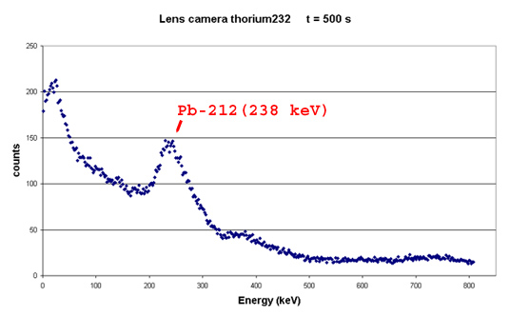

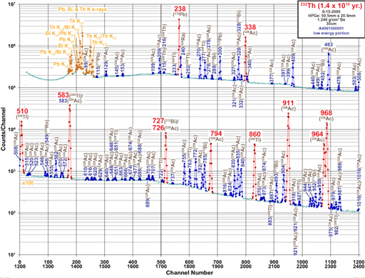

Bibliografia:
- Glenn F. Knoll, Radiation, detection and measurement. Second edition. Editorial John Wiley &Sons, 1989.
- Ortec Application Note, AN 34. Third edition, Published by EG&G Ortec, 1984.
- Jeromy Duggan, Laboratory investigations in nuclear science. Published by Tennelec and The Nucleus, 1988.
- Raymond A. Serway, Clement J. Moses, Curt A. Moyer. Modern Physics. Second edition. Editorial Saunders College Publishing, 1997.
- Kenneth S. Krane, Modern Physics. Second edition. John Wiley, 1996.
- Measurement and Detection of Radiation, Nicholas Tsoulfanidis Hemisphere Publishing Corporation, 1983

